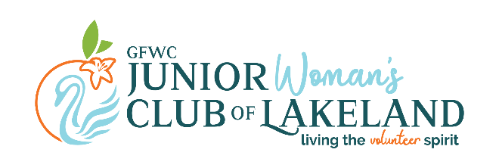

The GFWC Junior Woman’s Club of Lakeland is pleased to announce the Ninth Annual Live Green Lakeland EcoFest to the Lakeland community on November 11, 2023 at Munn Park in Downtown Lakeland. Live Green Lakeland will provide food, fun and entertainment for the entire family with the fundamental theme of living green in an open-air environment. The proceeds raised by Live Green Lakeland will be reinvested into the community projects and programs of the GFWC Junior Woman’s Club.
Children will enjoy eco-friendly crafts using recycled materials and adults have an opportunity to learn about local green organizations and resources. Live Green Lakeland incorporates many of the best parts of the Lakeland community to raise awareness about an important global cause and to encourage individuals to take small, attainable, steps to make a lasting difference. We expect to reach 3,000+ Polk County residents through this annual free event.
Reservations are now being taken for eco-friendly businesses and vendor areas and we feel that your organization would be a welcome addition to our event. We anticipate this area to be filled with an array of booths from various community organizations and would like to give you the opportunity to reserve your spot. To become a part of our event, fill in the information on the attached registration form with applicable fee. Upon receipt, you will receive a confirmation email. Located in the heart of downtown Lakeland, this eco-festival is a great opportunity to advertise your business.
The GFWC Junior Woman’s Club of Lakeland is excited about our popular annual event and we look forward to your involvement. If you would like more information on Live Green Lakeland 2023, please e-mail us at jwcoflakelandfl@gmail.com. Thank you for your consideration and we look forward to seeing you at Live Green Lakeland EcoFest!

Sincerely,

GFWC Junior Woman’s Club of Lakeland
Live Green Lakeland 2023
Vendor Committee

GFWC JUNIOR WOMAN’S CLUB OF LAKELAND
Live Green Lakeland EcoFest 2023
BOOTH REGISTRATION FORM
November 11, 2023, 8:00 a.m. to 2:00 p.m.
Deadline October 1 for early registration
After October 1 Vendor Fee increases to $40.00

Business Name: Website:
Contact Name: Phone:
Address: E-mail:
Instagram Handle: Facebook Page:
PLEASE SELECT ALL THAT APPLY: | COST | Qty | AMOUNT:
 | $35.00 (before October 1)  or  $40.00 (after Octoberber 1) | # of booths | # of booths x cost
 | $5.00 (deadline September 15) Select shirt size | # of shirts | # of shirts x cost
TOTAL: | Booth + shirt fees

- Description of booth/activities:
- Electrical outlet required? Yes
- Will you be holding a drawing or give away? If so, please provide details:

To apply online: Email application to jwcoflakeland@yahoo.com and pay via PayPal here.

To mail in your application: make checks payable to GFWC Junior Woman’s Club of Lakeland and send along with this form to:

GFWC Junior Woman's Club of Lakeland
P.O. Box 2604
Lakeland, FL 33806

